**‘AccessBank DBA Internship Program’**

**Project 13: Security Violation: SQL Profiler**

The IT Director has some concerns about data being violated by someone or something that is causing the data to be deleted.

The following discussion indicates that it’s the server called ‘XYZ’ and that is all that is known, you do not know from which database and from which table data is deleted.

The task at hand is for you to find out who or what is causing this critical data loss and fix the issue.

To emulate this scenario, you will have to use AdventureWorks2014 database and Person.Person table:

1. First of all, find the number of rows in the table before starting your simulation process:

**There are 19972 rows in that table and I found that by using following query:**

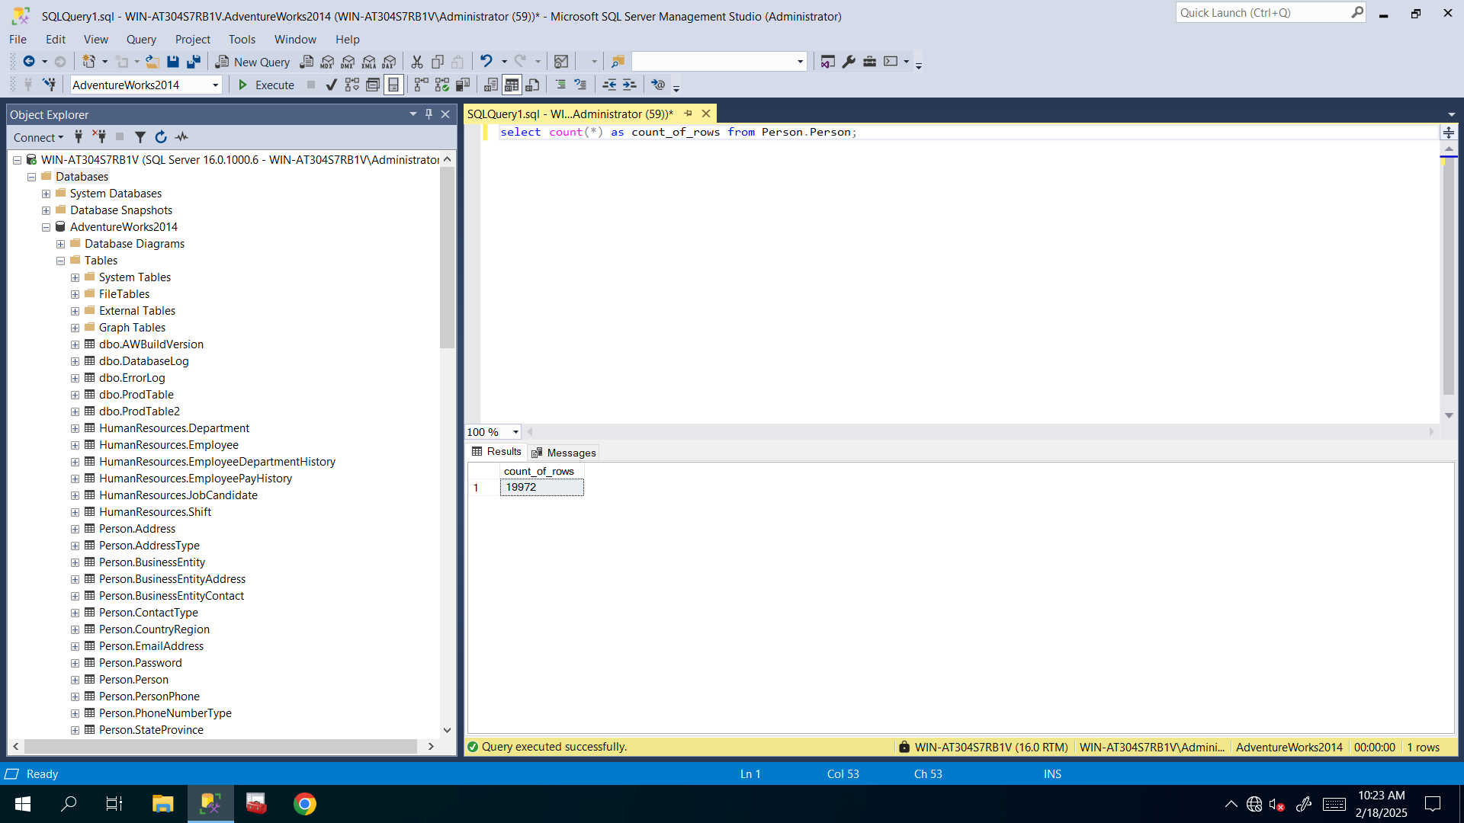

1. OPEN (NOT RUN AT THIS TIME) the SQL Profiler, name the profiler job as Delete_profiler, CHECK save the file to table in master database, select the following columns – textdata, applicationname, username, databasename, and UNCHECK every other box EXCEPT for these columns

**From Tools tab I selected SQL Server Profiler in order to create new trace and save it to the table:**

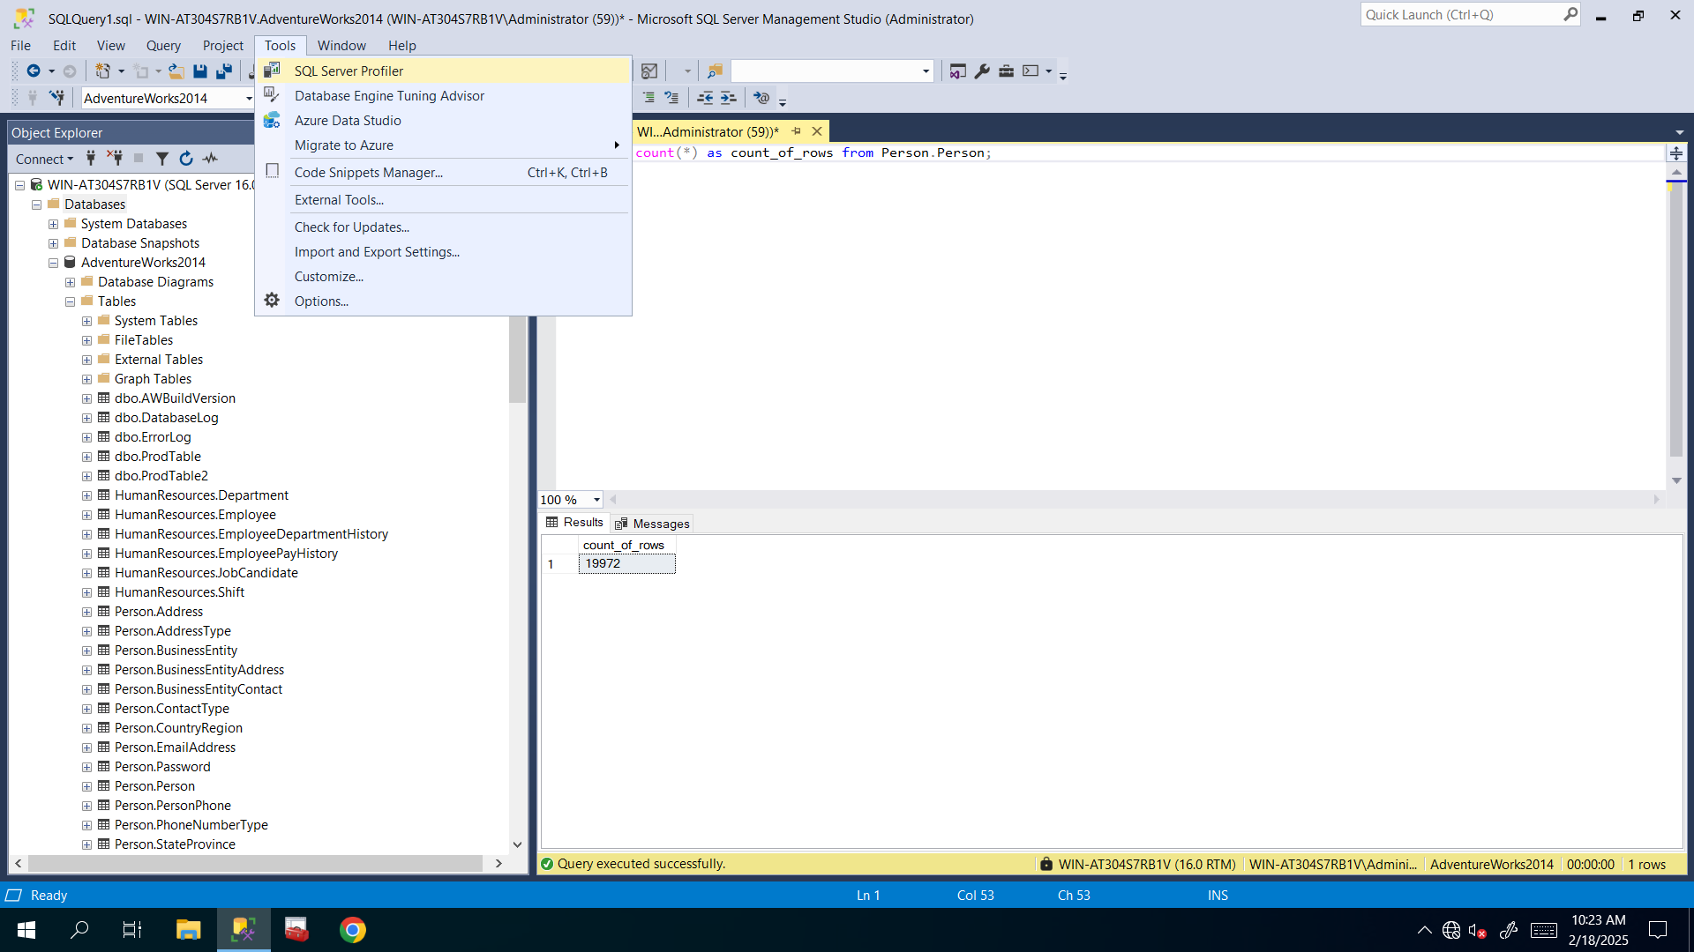

**I connected to that server in SQL Server Profiler window**: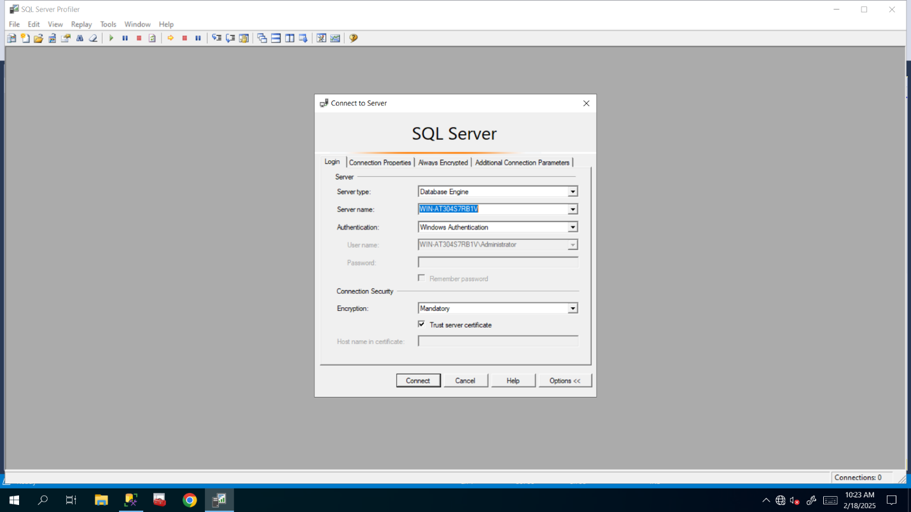

**Here I named it and selected save to table and here I selected master database as new table’s database**: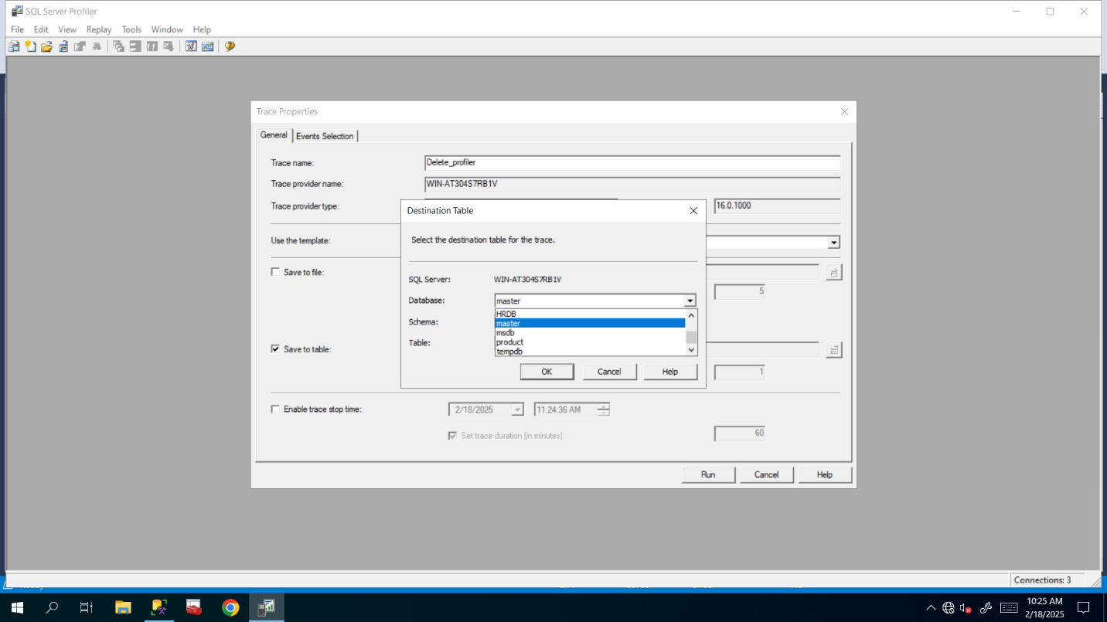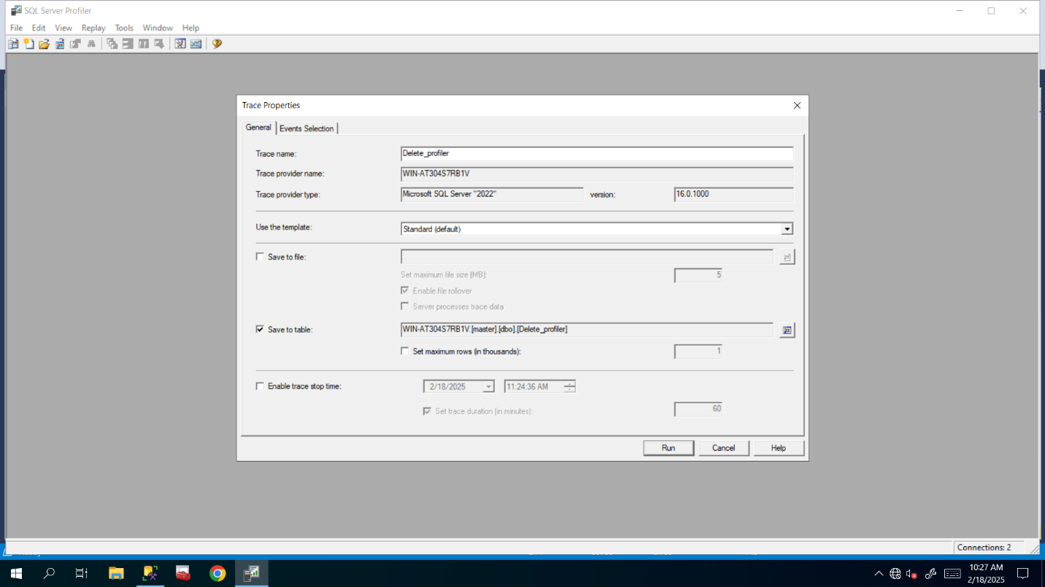

**Here I checked needed columns and unchecked others**: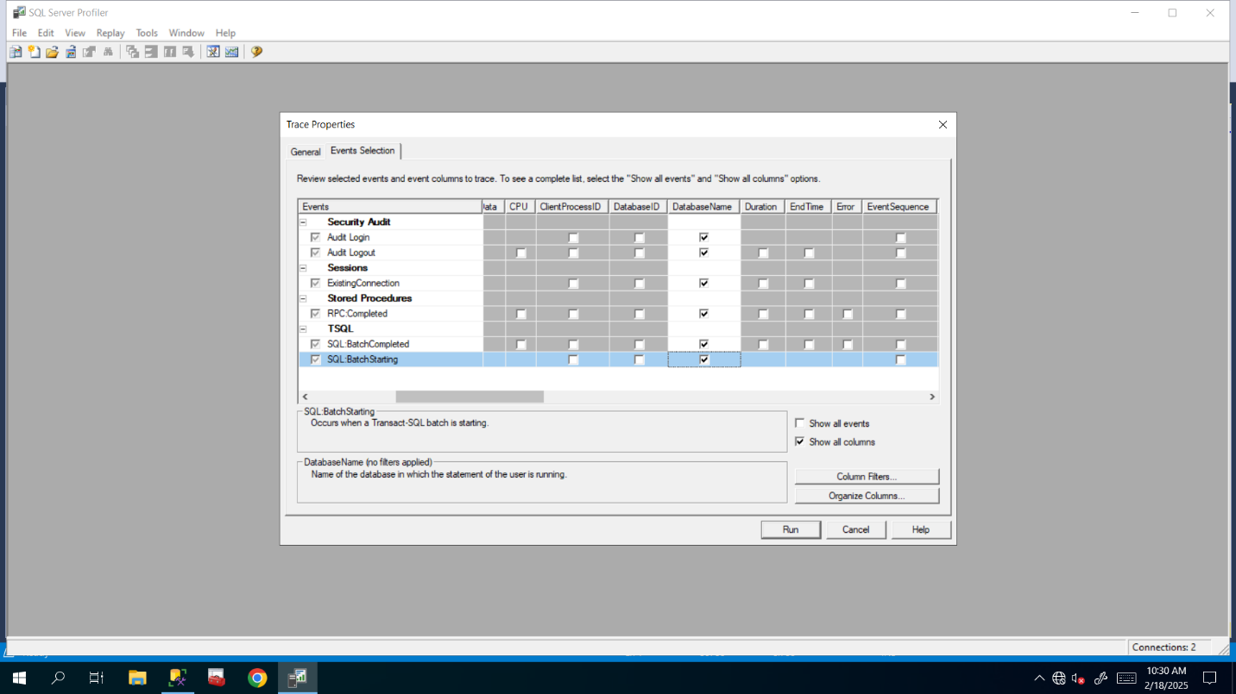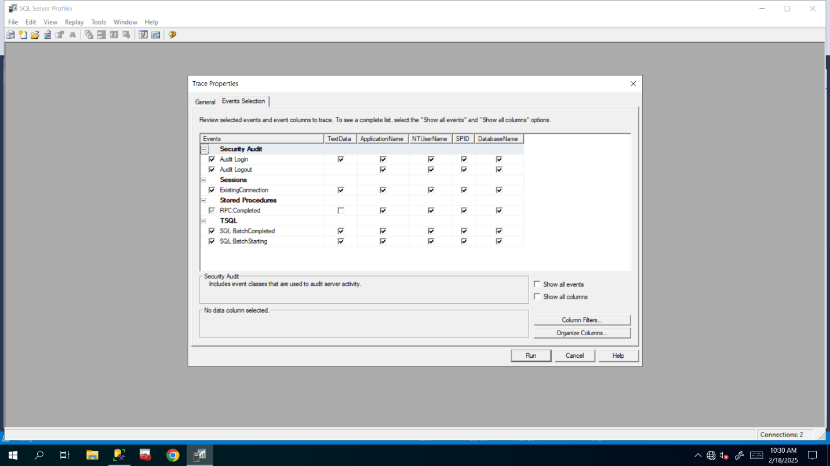

1. Create a job that executes this query every 1 min for 10 min duration (this will act as your 'hidden' cause of deletion)

**I created new maintenance plan and named its subplan and scheduled it as you said, but before these I selected Execute T-SQL Statement and dragged and dropped it and copied and pasted following query to create that job:**

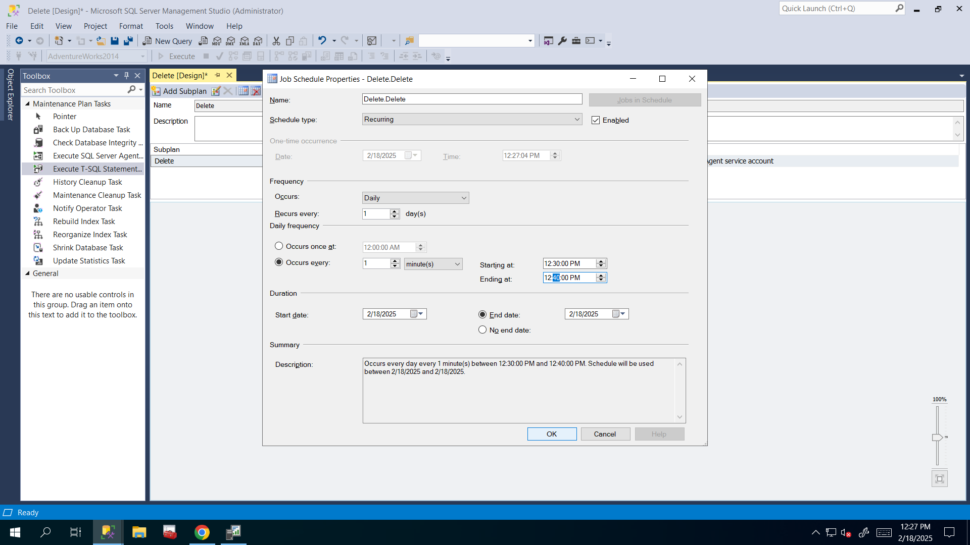

USE AdventureWorks2014

GO

DELETE TOP (10)

FROM [AdventureWorks2014].[Person].[Person]

GO

1. Run the SQL job delete, then run the SQL Profiler for 5 mins. Stop the profiler. Close the profiler. Go to Master database and look in the table’s folder for a folder called Delete. Analyze this data (filter it) and find the culprit that is causing the deletions (It should be the job you have created!!!)

**I did all of these above in following pictures and**

**after these I also looked at that everything is okay and it is that job that do these uncertain deletions and I looked at count of rows again to see how many rows are deleted and**

**because of several errors that late me up to send this project, there are lots of rows deleted and 19832 rows are in there so 140 rows are deleted, but most part of it deleted when I solve issues and errors.**

